**My Project output file to the R code**

**Summarizing the dataset:**

str(sensexmovements.df)

Output:

'data.frame': 738 obs. of 10 variables:

$ Date : Factor w/ 738 levels "1/1/2014","1/1/2015",..: 1 23 47 54 57 60 63 4 8 11 ...

$ SENSEX.BO :num 21140 20888 20851 20787 20693 ...

$ TCS.BO :num 2154 2162 2222 2240 2208 ...

$ TATAMOTORS.BO :num 375 372 363 367 365 ...

$ SUNPHARMA.BO :num 572 574 580 588 594 ...

$ ITC.BO :num 322 315 315 316 317 ...

$ INFOSYS.BO :num 3466 3475 3565 3514 3457 ...

$ ICICIBANK.BO :num 1097 1075 1067 1041 1050 ...

$ AXISBANK.BO :num 6459 6364 6303 6280 6172 ...

$ ASIANPAINTS.BO: num 500 486 489 490 490 ...

summary(sensexmovements.df)

ouput:

Date SENSEX.BO TCS.BO TATAMOTORS.BO SUNPHARMA.BO ITC.BO

1/1/2014 : 1 Min. : 0 Min. : 0 Min. : 0.0 Min. : 0.0 Min. : 0.0

1/1/2015 : 1 1st Qu.:25202 1st Qu.:2293 1st Qu.:377.0 1st Qu.: 706.7 1st Qu.:314.0

1/1/2016 : 1 Median :26456 Median :2471 Median :433.2 Median : 798.5 Median :327.8

1/10/2014: 1 Mean :25803 Mean :2367 Mean :414.4 Mean : 763.6 Mean :321.4

1/11/2016: 1 3rd Qu.:27811 3rd Qu.:2558 3rd Qu.:503.6 3rd Qu.: 856.8 3rd Qu.:349.9

1/12/2015: 1 Max. :29682 Max. :2776 Max. :605.1 Max. :1168.5 Max. :399.6

(Other) :732

INFOSYS.BO ICICIBANK.BO AXISBANK.BO ASIANPAINTS.BO

Min. : 0 Min. : 0.0 Min. : 0.0 Min. : 0.0

1st Qu.:1084 1st Qu.: 258.3 1st Qu.: 0.0 1st Qu.: 585.9

Median :1229 Median : 308.3 Median : 474.5 Median : 814.7

Mean :2002 Mean : 608.5 Mean : 1696.4 Mean : 736.5

3rd Qu.:3202 3rd Qu.:1077.9 3rd Qu.: 580.1 3rd Qu.: 882.1

Max. :4367 Max. :1793.1 Max. :10115.8 Max. :1212.9

BOX plot for the independent varaibleTCS.Bo:

Output:

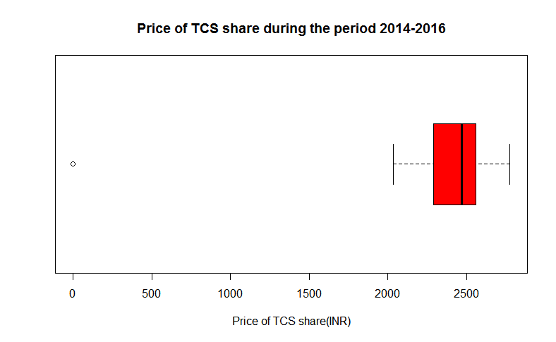

BOX plot for the independent varaibleICICIBANK.Bo:

Ouput:

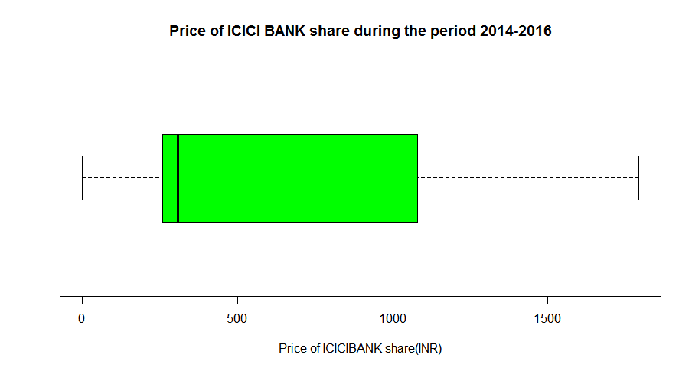

BOX plot for the independent varaibleASIANPAINTS.Bo:

Output:

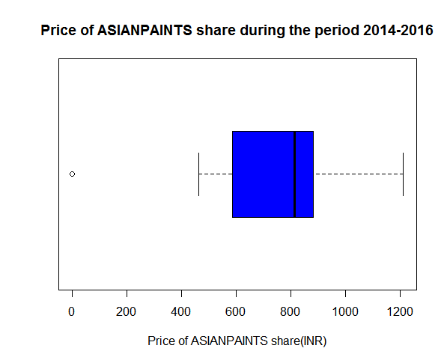

Scatter plot of SENSEX.BO and TCS.BO:

Output:

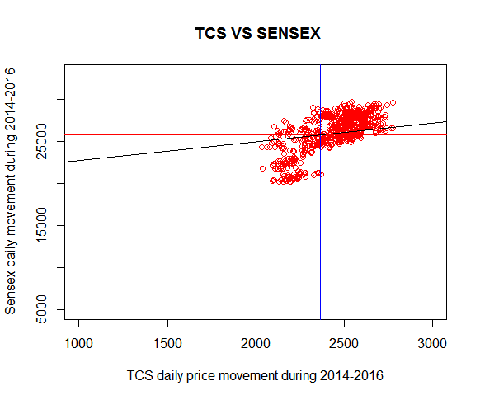

Scatter plot of SENSEX.BO and ICICIBANK.BO:

Output:

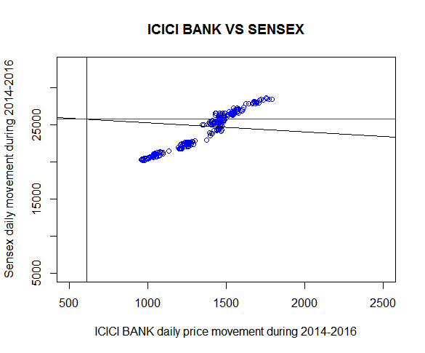

Scatter plot of SENSEX.BO and ASIAN PAINTS.BO:

Output:

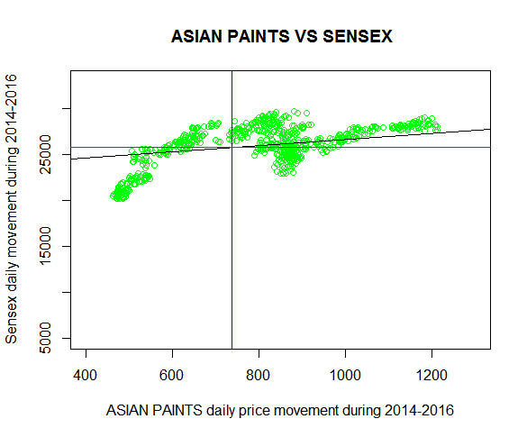

Drawing variance-covariance matrix:

Output:

>sensexsub.df<-sensexmovements.df[,c(2,3,8,10)]

>cov(sensexsub.df)

SENSEX.BO TCS.BO ICICIBANK.BO ASIANPAINTS.BO

SENSEX.BO 12853113.6 440137.467 -336997.372 256146.04

TCS.BO 440137.5 198805.077 9344.923 33687.51

ICICIBANK.BO -336997.4 9344.923 268535.901 -53758.84

ASIANPAINTS.BO 256146.0 33687.512 -53758.844 77814.22

Drawing a corrgram:

Output:

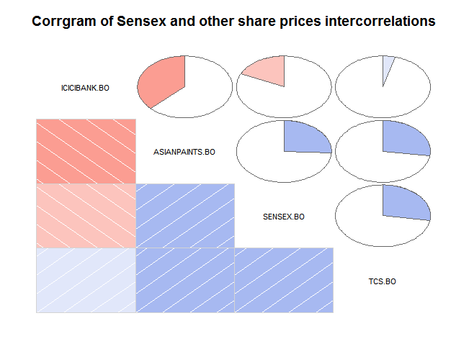

t-testsfor testing hypotheses:

t.test(sensexmovements.df$SENSEX.BO - sensexmovements.df$TCS.BO)

output:

One Sample t-test

data: sensexmovements.df$SENSEX.BO - sensexmovements.df$TCS.BO

t = 182.48, df = 737, p-value < 2.2e-16

alternative hypothesis: true mean is not equal to 0

95 percent confidence interval:

23183.34 23687.58

sample estimates:

mean of x

23435.46

t.test(sensexmovements.df$SENSEX.BO - sensexmovements.df$ICICIBANK.BO)

One Sample t-test

data: sensexmovements.df$SENSEX.BO - sensexmovements.df$ICICIBANK.BO

t = 184.27, df = 737, p-value < 2.2e-16

alternative hypothesis: true mean is not equal to 0

95 percent confidence interval:

24925.96 25462.79

sample estimates:

mean of x

25194.37

t.test(sensexmovements.df$SENSEX.BO - sensexmovements.df$ASIANPAINTS.BO)

One Sample t-test

data: sensexmovements.df$SENSEX.BO - sensexmovements.df$ASIANPAINTS.BO

t = 193.23, df = 737, p-value < 2.2e-16

alternative hypothesis: true mean is not equal to 0

95 percent confidence interval:

24811.63 25320.97

sample estimates:

mean of x

25066.

Linear Regression Models using lm():

fit <- lm(SENSEX.BO ~ TCS.BO + ICICIBANK.BO + ASIANPAINTS.BO, data=sensexmovements.df)

fit

Output:

Call:

lm(formula = SENSEX.BO ~ TCS.BO + ICICIBANK.BO + ASIANPAINTS.BO,

data = sensexmovements.df)

Coefficients:

(Intercept) TCS.BO ICICIBANK.BO ASIANPAINTS.BO

20447.3564 1.9586 -0.9677 1.7753

summary(fit)

Call:

lm(formula = SENSEX.BO ~ TCS.BO + ICICIBANK.BO + ASIANPAINTS.BO,

data = sensexmovements.df)

Residuals:

Min 1Q Median 3Q Max

-26487.8 -1092.0 599.8 1452.6 7707.8

Coefficients:

Estimate Std. Error t value Pr(>|t|)

(Intercept) 20447.3564 712.8694 28.683 < 2e-16 ***

TCS.BO 1.9586 0.2916 6.717 3.72e-11 ***

ICICIBANK.BO -0.9677 0.2602 -3.719 0.000215 ***

ASIANPAINTS.BO 1.7753 0.5017 3.539 0.000427 ***

---

Signif. codes: 0 ‘***’ 0.001 ‘**’ 0.01 ‘*’ 0.05 ‘.’ 0.1 ‘ ’ 1

Residual standard error: 3355 on 734 degrees of freedom

Multiple R-squared: 0.1278, Adjusted R-squared: 0.1243

F-statistic: 35.86 on 3 and 734 DF, p-value: < 2.2e-16